# Bonus Assignment

## Part 1

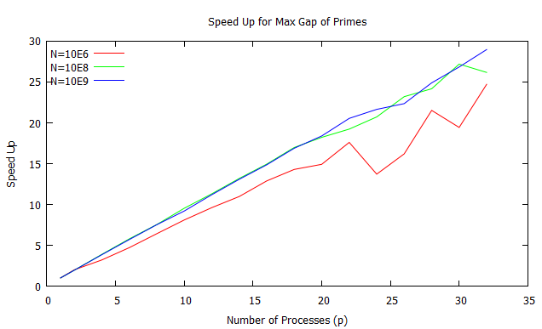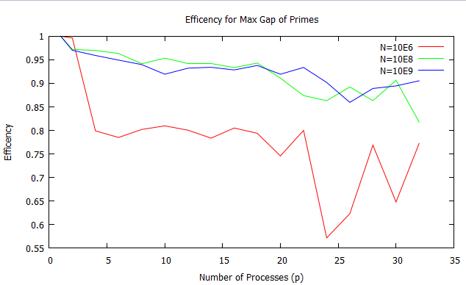

## Part 2

The following results were the result of 32 processes and b=109.The min time was 5.68e+01s and the max time was 8.22e+01. This is fairly large of a gap but they are definitely not the norm. There is a fairly small standard deviation about 1.5e+01.I am concluding that they are nearly the same. There is a growth pattern that emerges which I will claim to be a result of nextPrime enforcing the primes to be probably prime (value of 1 or 2). This will increasingly take longer to generate the next prime because the testing for such large numbers takes much longer.

32 1000000000 5.71e+01

32 1000000000 5.68e+01

32 1000000000 5.74e+01

32 1000000000 5.77e+01

32 1000000000 5.82e+01

32 1000000000 5.69e+01

32 1000000000 5.85e+01

32 1000000000 5.86e+01

32 1000000000 5.74e+01

32 1000000000 5.82e+01

32 1000000000 5.88e+01

32 1000000000 5.88e+01

32 1000000000 5.92e+01

32 1000000000 5.94e+01

32 1000000000 5.99e+01

32 1000000000 5.79e+01

32 1000000000 5.85e+01

32 1000000000 6.06e+01

32 1000000000 6.05e+01

32 1000000000 6.06e+01

32 1000000000 6.03e+01

32 1000000000 6.07e+01

32 1000000000 6.09e+01

32 1000000000 6.17e+01

32 1000000000 6.09e+01

32 1000000000 6.13e+01

32 1000000000 5.81e+01

32 1000000000 5.88e+01

32 1000000000 7.96e+01

32 1000000000 8.22e+01

32 1000000000 6.33e+01

Max gap: 282

## Part 3

I had to estimate 109 on 1 process as twice as long as 109 on 2 processes because it would not compute within the 30 minutes. This is representative of the limit for 1 process. Using all 32 processors I was able to compute up to 15E9 on 32 processors. I currently have jobs running to compute more but due to time constraints I will have to estimate that the highest value for which I can compute is approximately 100E9.

## Part 4

I could not compute up to b =1012 because the time limit enforced on wobbie for our sharcnet accounts limits us to 30 minutes. I could not compute 109 on 1 process in 30 minutes so I could not compute 3.125E10 on each of the 32 processes either.

The time it takes to test each prime and generate a probable prime (error of 1/250 ) becomes increasingly larger for each prime. This very well could overwhelm the computation time of each incremental gap.